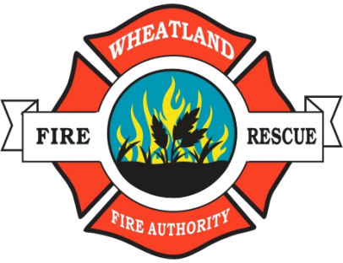 | Wheatland Fire Authority
 | P.O. Box 119 313 Main Street Wheatland, California 95692
 | Telephone (530) 633-0861 Fax (530) 633-8215 www.wheatlandfireauthority.com

WHEATLAND FIRE AUTHORITY
BOARD OF DIRECTORS

NOTICE OF MEETING CANCELLATION

Notice is hereby given that the regular Wheatland Fire Authority meeting to be held on October 12, 2023 @ 6:00pm at 4514 Dairy Road, Wheatland CA is cancelled.

October 5, 2023
Bart Johnson, WFA Board Chair

