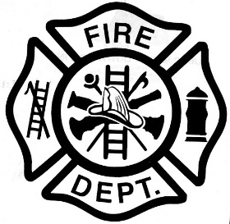 | Plumas-Brophy Fire Protection Dist.
 | P.O. Box 119 313 Main Street Wheatland, California 95692
 | Telephone (530) 633-0861 Fax (530) 633-8215 www.wheatlandfireauthority.com

PLUMAS-BROPHY FIRE PROTECTION DISTRICT BOARD OF DIRECTORS
EMERGENCY MEETING NOTICE

NOTICE IS HEREBY GIVEN that the Chair of the Plumas-Brophy Fire Protection District Board of Directors have called an EMERGENCY meeting of the Board of Directors to be held on November 29, 2021, at 6:00 p.m. at the Wheatland Fire Authority Station No. 3, 4514 Dairy Road, Wheatland, California.
Members of the public may address the Board of Directors concerning any item described below during the Board’s consideration of that item. The Chair will invite public comment following Board discussion/deliberation of the item and, if applicable, before Board action.
In compliance with the Americans with Disabilities Act, if you are a disabled person and you need a disability-related modification or accommodation to participate in this meeting, please contact Art Paquette (WFA Fire Chief) for any requests. This must be made as early as possible and at least one-full business day before the start of the meeting.

The following business shall be considered and transacted:
1. Call to order and roll call.
2. Pledge of Allegiance to the Flag.
3. At this time, the public is permitted to address the Board on non-agenized items. COMMENTS SHOULD NOT EXCEED THREE (3) MINUTES. In accordance with State Law, however, no action or discussion may take place on any item not appearing on the posted agenda. The Board may respond to statements made or questions asked or may request Staff to report back at a future meeting concerning the matter. Any member of the public may contact the Secretary related to the proper procedure to place an item on a future Plumas-Brophy Fire Protection District agenda. The exceptions under which the Board MAY discuss and/or act on items not appearing on the agenda are contained in Government Code §54954.2(b) (1) (2) (3).
4. Measure K
5. Adjourn

