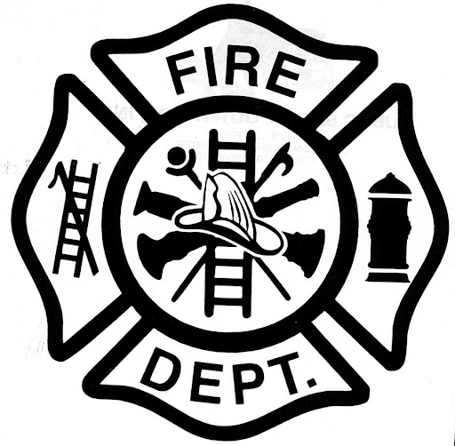 | Plumas-Brophy Fire Protection Dist.
 | P.O. Box 119 313 Main Street Wheatland, California 95692
 | Telephone (530) 633-0861 Fax (530) 633-8215 www.wheatlandfireauthority.com

March 10,2022 MINUTES
WHEATLAND FIRE AUTHORITY
BOARD OF DIRECTORS – REGULAR MEETING

This was a regular meeting of the appointed Board of Directors for the Wheatland Fire Authority (WFA), a joint powers authority of the Plumas-Brophy Fire Protection District and City of Wheatland.

1.0 & 2.0 Call to order, roll call and Pledge of Allegiance to the flag at 6:24 p.m.
Directors present: Chairman Martin Heatlie, Bart Johnson, John Eachus
Also present – Fire Chief Art Paquette, Bookkeeper Kathy Herbert.

3.0 Public Comment - None

4.0 Minutes: Board Member Johnson made a motion to accept minutes as read, Board Chairman Heatlie seconded.

Vote called – AYES Motion carried

5.0 Reports

Measure K funds were discussed. The Board asked that Chief Paquette bring quotes and information on needed equipment to the next Board meeting. A second set of Jaws were discussed at a cost of $ 44,771.78 as well as the purchase of 3 TICS at a cost of $ 5,519.00 per set. The Board also requested a quote for 8 sets of Firefighters gear.

Board direction was given to Chief Paquette to fund $ 50,000.00 toward the purchase of a new vehicle for the Chief. A provision was made that the City of Wheatland is to match the contribution and the arrangement be brought before the Wheatland Fire Authority for approval in April 2022.

Fire Chief A. Paquette presented a check payable to Plumas Brophy Fire District for
$ 100,530.96 for full payment of the loan made to Wheatland Fire Authority in November 2021 in the amount of $100,000.00 as well as interest due in the amount of $ 530.96.

Board Member John Eachus announced his resignation effective at the Board Meeting of May 12, 2022.

6.0 There being no further business, the meeting was adjourned at 7:06 p.m.

7.0 Minutes approved and adopted this 14th day of April 2022.

Prepared by Kathy A. Herbert
April 7, 2022

