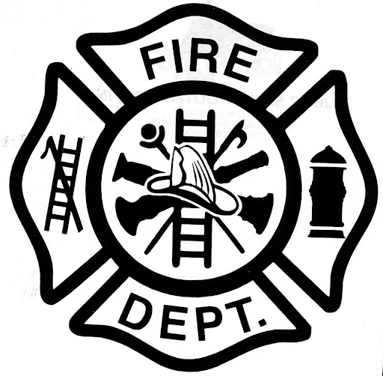 | Plumas-Brophy Fire Protection Dist.
 | P.O. Box 119 313 Main Street Wheatland, California 95692
 | Telephone (530) 633-0861 Fax (530) 633-8215 www.wheatlandfireauthority.com

PLUMAS-BROPHY FIRE PROTECTION DISTRICT
BOARD OF DIRECTORS

NOTICE OF MEETING CANCELLATION

Notice is hereby given that the regular Plumas-Brophy Fire Protection District meeting to be held on December 14, @ 6:30pm at 4514 Dairy Road, Wheatland CA is cancelled.

December 11, 2023
Martin Heatlie, PBFPD Board Chair

